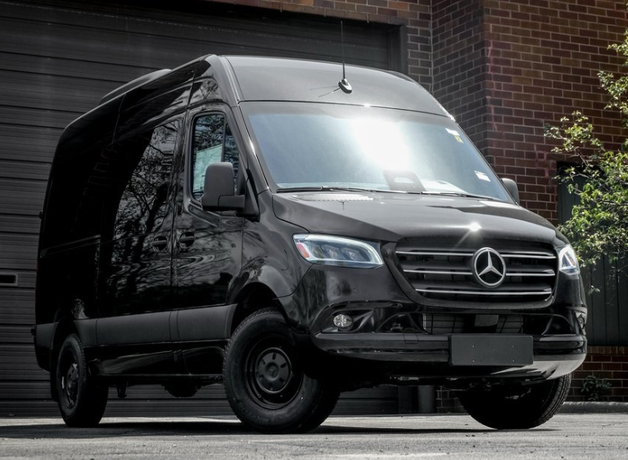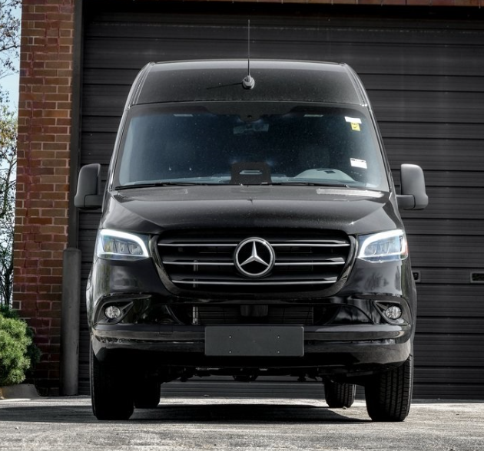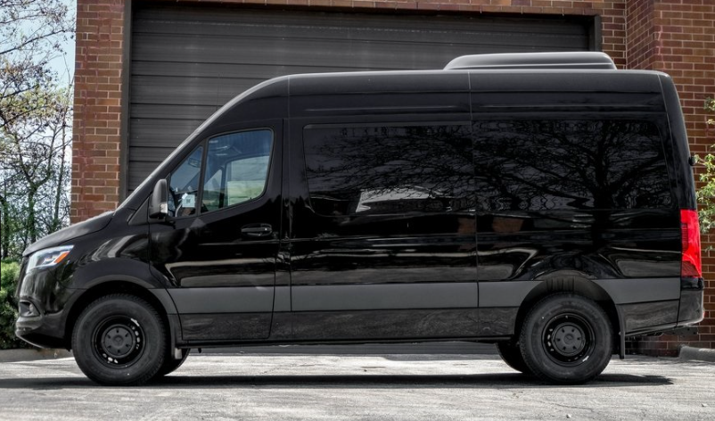

Main Specification Of Mercedes Benz Sprinter

## 🚚 Powertrain & Performance

* **Engine**: 2.0 L inline‑4 intercooled turbo‑diesel
  + Standard output: 168 hp @ 3,800 rpm and 295 lb‑ft @ 1,400 rpm
  + High‑Output option: 208 hp and 332 lb‑ft
* **Transmission**: 9‑speed automatic with optional manual shift mode
* **Drivetrain**: Rear‑wheel drive; AWD available with high‑output engine

**📐 Dimensions & Capacities**

* **Overall Length**:
  + Standard (144″ WB): ~5,931 mm (233.5″)
  + Long (170″ WB): ~6,967 mm (274.3″)
* **Width**: 2,032 mm (80.0″) **Height**:
  + Standard roof: ~2,446 mm (96.3″)
  + High roof: up to ~2,725 mm (107.3″)
* **Wheelbase**: 3,658 mm (144″) or 4,318 mm (170″)
* **Ground Clearance**: ~203 mm (8.0″)

**⚖️ Weight & Load**

* **Curb Weight**: ~2,240 – 2,390 kg (4,938 – 5,269 lb) depending on configuration
* **GVWR**: ~4,105 kg (9,050 lb)
* **Payload Capacity**: up to ~1,865 kg (4,112 lb) for cargo vans
* **Towing Capacity**: ~2,268 kg (5,000 lb)

**🛋️ Space & Seating**

* **Passenger Capacity**:
  + Cargo version: 2 front seats
  + Passenger van: up to 12 seats
* **Cargo Volume (2500 cargo)**: ~319 cu ft (9,033 L)
* **Interior Dimensions (144″ WB)**:
  + Front headroom: ~1,201 mm (47.3″)
  + Legroom: ~988 mm (38.9″)
  + Hip/Shoulder: ~1,618 mm (63.7″) / ~1,712 mm (67.4″)

**🛠️ Chassis & Running Gear**

* **Suspension**: Independent front; rear torsion beam with coil springs
* **Brakes**: 4‑wheel disc brakes with ABS, brake assist, stability & traction control
* **Steering**: Power-assisted rack‑and‑pinion (turning radius ~6.2–6.6 m)

**✅ Features & Safety**

* **Safety Systems**: Crosswind Assist, Active Brake Assist, lane-keeping, driver & curtain airbags, rear‑cross traffic alert
* **Convenience**: Split‑swing cargo doors, power/heated mirrors, optional rear‑view camera
* **Infotainment**: MBUX system (touchscreen with Bluetooth), AM/FM radio, steering wheel controls, cruise control
* **Warranty**: 3 yr/36,000 mi basic; 5 yr/100,000 mi powertrain; roadside assistance included

**🚀 Summary**

The 2025 Sprinter 2500 blends strong diesel performance with heavy-duty capacity:

* Compact yet flexible size: lengths 233–274″, heights up to ~107″
* Efficient turbo-diesel engines (168 hp or 208 hp HO) with 9-speed auto
* Payload up to ~1,865 kg and towing of 2,268 kg
* Cargo vans offer ~9,033 L space; passenger versions fit up to 12
* Robust safety and utility features with long warranties